**OSI MODEL– OPEN SYSTEM INTERCONNECTION**

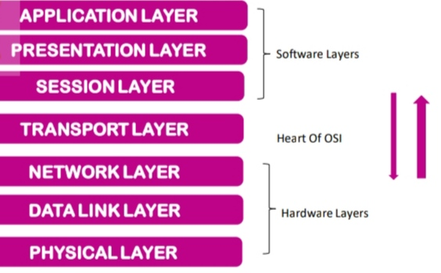

7 Layer Architecture

having specific functionality.

All these 7 layers work

collaboratively to transmit the data from one

person to another across globe.

The OSI Model is a conceptual framework

used to describe the functions of a networking system.

In 1984,the OSI architecture was formally adopted by ISO as an international standard.

**DATA UNITS OF EACH LAYERS**

#### 

### **Roles & Protocols Used At Each Layer**

### 

**APDU**– Application protocol data unit.

**PPDU**– Presentation protocol data unit.

**SPDU**– Session protocol data unit.

**TPDU**– Transport protocol data unit (Segment).

**Packet**– Network layer host-router protocol.

**Frame**– Data-link layer host-router protocol.

**Bits**– Physical layer host-router protocol.

**DEVICES USE OF EACH LAYER**

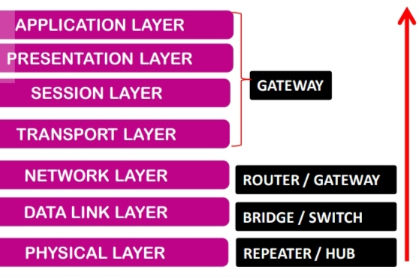It helps you to standardize router, switch, motherboard, and other hardware.

Reduces complexity and standardizes interfaces.

It is a standard model in computer networking.

Supports connectionless and connection-oriented services.

Offers flexibility to adapt to various types of protocols.

**LAYER 1 = PHYSICAL LAYER**

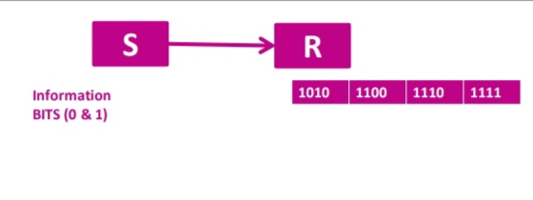

PHYSICAL CONNECTION BETWEEN DEVICES.

PHYSICAL LAYERS (0’s ,1’s) ---- DATA LINK LAYER (Use Frames).

layer 1 devices include hubs, repeaters & Ethernet cable connectors.

These are the basic devices that are used at the physical layer to transmit data through a given physical medium which is suitable as per the network need.

The physical layer is the first and bottom-most layer of the OSI Reference Model. It mainly provides the bitstream transmission.

Usually, star, bus or ring topologies are used for networking and the modes used are half-duplex, full-duplex or simplex.

FUNCTION OF **PHYSICAL LAYER**

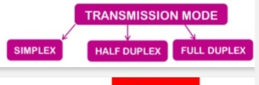

1.BIT SYNCHRONIZATION

For Synchronization , uses clock.

Clock = controls both sender and receiver.

2.BIT RATE CONTROL

BIT RATE = TRANSMISSION RATE

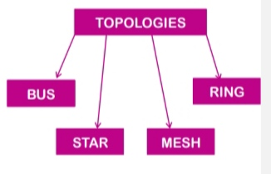BIT RATE = NO. OF BITS SENT PER SECOND

Numerically , Bit Rate = Bit/Second = Bit/Time

3.PHYSICAL TOPOLOGIES

Defines the way in which different devices/nodes are arranged in a network.

4.TRANSMISSION MODE

Defines the way in which data flows.

**LAYER 2 = DATA LINK LAYER**

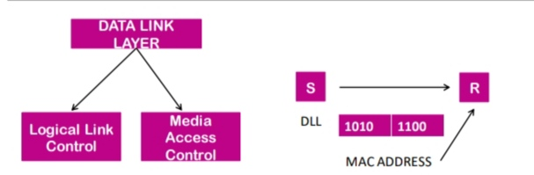

NODE – TO- NODE MESSAGE DELIVERY.

DATA ERROR FREE.

PROCESS - MAC ADDRESS OBTAINED BY.

PLACING ARP REQUEST ONTO WIRE.

AND ASKING WHO HAS THAT IP

ADDRESS.

THEN THAT HOST REPLY WITH MAC

ADDRESS.

**FUNCTIONS OF DATA LINK LAYER**

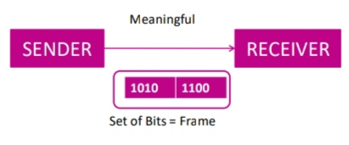

1.FRAMING

Accomplished by attaching special bit

pattern to beginning and end of frame.

**2.PHYSICAL ADDRESSING**

Adding Physical addresses =

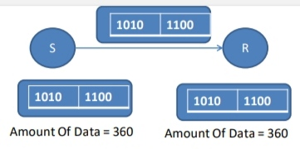MAC addresses of both sender and receiver in frame.

**3.ERROR CONTROL**

Detects and re-transmits lost frames.

**4.FLOW CONTROL**

S = R (Constant Data)

**5.ACCESS CONTROL**

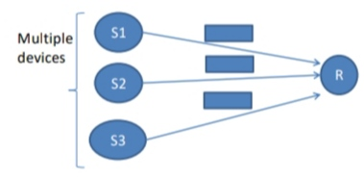When multiple devices access the

single communication channel, then ?

MAC Layer of DLL determine

which device (S1 , S2, S3) has control over channel.

**LAYER 3.NETWORK LAYER**

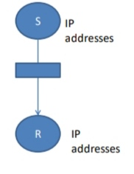

RESPONSIBILTY For PACKET ROUTING.

Uses IP Addresses of Both Sender and

Receiver.

FUNCTION 1.Routing (Which Route is suitable)

FUNCTION 2.Logical Addressing = IP Address

Why ?

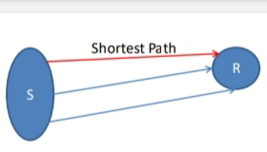To Uniquely Identify each Device.

**LAYER 4. TRANSPORT LAYER**

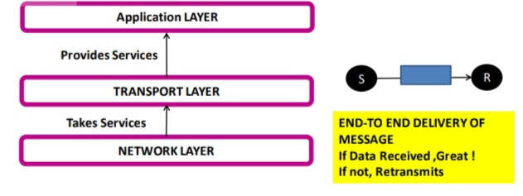**At Sender’s Site**

1. Transport layer receives Formatted

data from Network Layer.

2. To Ensure Proper Data

Transmission , performs Segmentation and implements Flow and error control.

3.Sender need to know port no. with receiver application.

**At Receiver’s Site**

1. Transport layer performs Sequencing & Reassembly of the segmented data.

**FUNCTIONS OF TRANSPORT LAYER**

**1. SEGMENTATION AND REASSEMBLY**

Transport layer accepts the message from session layer and breaks into smaller units.

Transport layer at destination station reassembles the message.

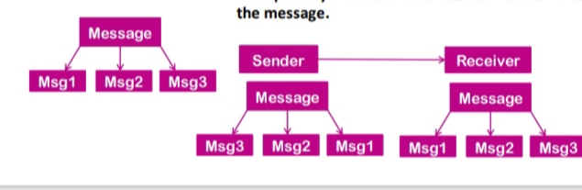

**2 .SERVICE POINT ADDRESSING**

Deliver message to the correct person.

For this, Transport layer header includes a type of address called Service Point address or Port Address.

By Specifying Service Port address , transport layer make sure that the message is delivered to correct person.

**LAYER 5. SESSION LAYER**

**1.SESSION ESTABLISHMENT , MAINTAINANCE AND TERMINATION.**

**2.SYNCHRONIZATION**

ADD Checkpoints = Synchronization Point

Which helps to identify the error so that the data can be re-synchronized.

**3.DIALOG CONTROLLER**

Session Layer Determines which device will communicate first and the amount of data will be sent.

Message is compressed ,encrypted and converted into bits (0 & 1) to transmit.

**LAYER 6. PRESENTATION / TRANSLATION LAYER**

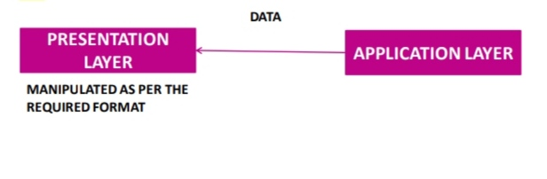

**1.TRANSLATION**

ASCII --------- EBCDIC

**2.ENCRYPTION / DECRYPTION**

ENCRYPTED DATA = CIPHER TEXT

DECRYPTED DATA = PLAIN TEXT

A key value is used for encrypting as well as decrypting data.

**3.COMPRESSION (Reduce no. of bits that need to be transmitted)**

**LAYER 7. APPLICATION LAYER**

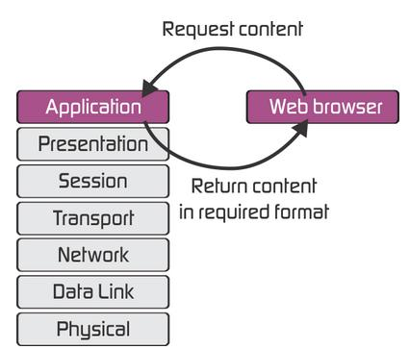

Implemented by Network Application. Serves as Window.

Ex – Browser ,Skype etc.

Also called Desktop layer.